To what extent is mitigation better than adaptation in tackling climate change? [9 marks]
In your book
- Write out the question
- BUG it!
- What does the command term mean?
- Define the key geographical terms in the question.
- Name the case study you would use
Plan your answer
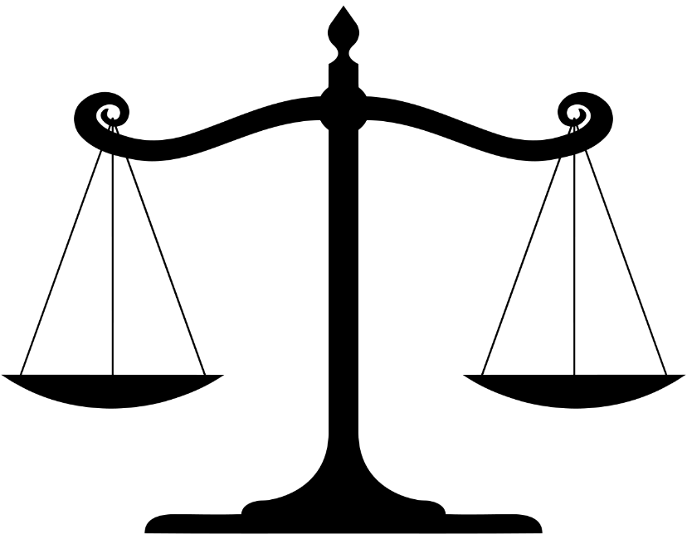
- Introduction – use the key geographical terms from the question, show your understanding of the terms.
- Positives of mitigation, any negatives?
- Positives of adaptation, any negatives?
- Make a judgement and explain it.
- Conclude your overall findings.

Remember with a ‘to what extent’ question you are making a judgement.

