Christchurch- New Zealand

Background information
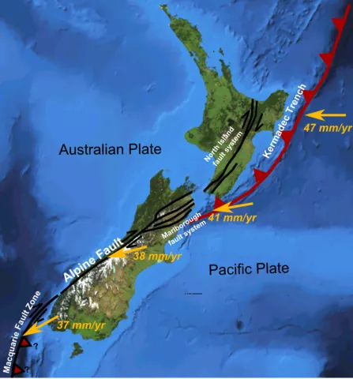
New Zealand is located in the continent of Oceania in the Pacific Ocean. It is to the south east of Australia and consists of both a North and South Island. The Earthquake occurred in Christchurch on the 22nd of February 2011 at 12:51 and reached a magnitude of 6.3
Causes
New Zealand is along the Australian and Pacific plate boundary (conservative plate margin). The earthquake was caused when the Pacific plate slid past the Australian plate in the other direction.

Effects

Primary | Secondary
181 people were killed and around 2,000 people were injured | Business were put out of action for long periods causing losses of income and jobs
Hundreds of kilometres of water and sewage pipes were damaged | Schools had to share classrooms because of the damage to other school buildings
50% + of Central City buildings severely damaged including the city’s cathedral which lost its spire | Damage to roads through liquefaction made it difficult for people and emergency services to move around
Liquefaction (where the ground gets saturated and loses strength) caused lots of damage to roads and buildings | People were affected mentally by the earthquakes and needed support
Part (size of 20 football fields) of the country’s longest glacier was broken off creating a large iceberg | Christchurch could no longer host Rugby World Cup matches so lost the benefits, e.g. tourism and income, they would bring
80 percent of the city was out of electricity

#

Response
Short Term Response | Long Term Response
Cared for the most vulnerable people and ensured people were safe from dangerous buildings | Paid $898 million in building claims
Chemical toilets were provided for 30,000 residents | Provided temporary housing and ensured all damaged housing was kept water tight
Areas were zoned (green, orange, white, red) to classify damage/cost of repairs | Water and sewerage was restored for all residents by August
International aid was provided in the form of money (around $6-7 million) and aid workers | Roads and houses were cleared of silt from liquefaction by August and 80% of roads/50% of footpaths were repaired

